Mission Design Activity
Different bodies of water around the globe are shrinking and disappearing, these changes to vital bodies of water have many effects on the natural environment surrounding them as well as the human and animal populations that rely on them.
Lake Chad has shrunk by 90% since the 1960s, due to climate change, an increase in the population and unplanned irrigation. Its basin covers parts of Nigeria, Niger, Chad and Cameroon, and has been a water source for between 20 million and 30 million people. But with the desert encroaching further every year, it is getting increasingly difficult for families to make a living through agriculture, fishing and livestock farming. Increased desertification as the water resources disappear is also affecting the animal populations that live in, breed, or migrate through these areas. Lake Chad offers a cautionary tale that can inform our anticipation of the potential impact of climate change in many parts of Africa. It shows the close interconnections between ecological change, security, and development.
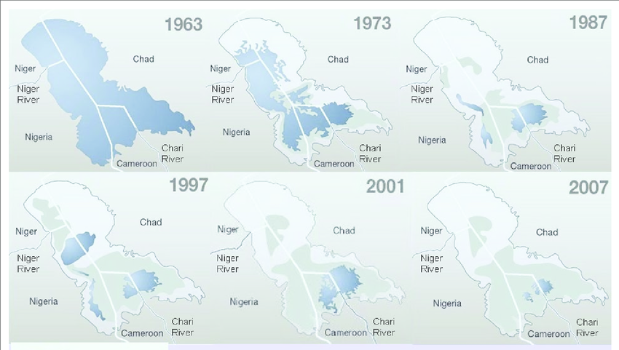

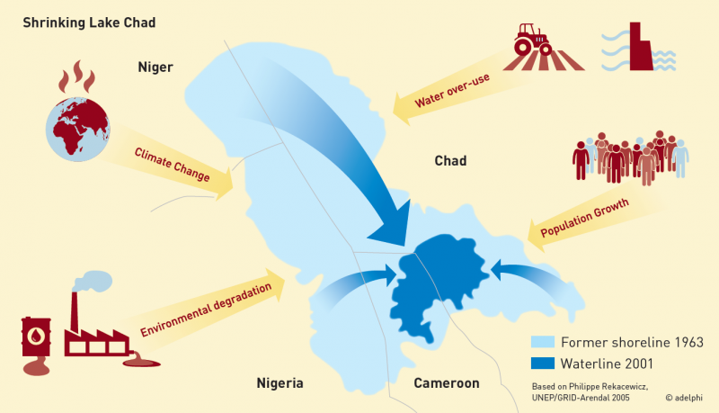

For this exercise, we are going to be using Lake Victoria in Africa as our body of water to study.
Lake Victoria is Africa's largest lake by area, the world's largest tropical lake, and the world's second largest fresh water lake by surface area. Its shorelines extend through three countries: Uganda, Kenya, and Tanzania. With increasing populations in these areas and governments relying on the lake for agricultural uses and hydroelectric power, Lake Victoria is shrinking and vulnerable to following in Lake Chad’s footsteps.

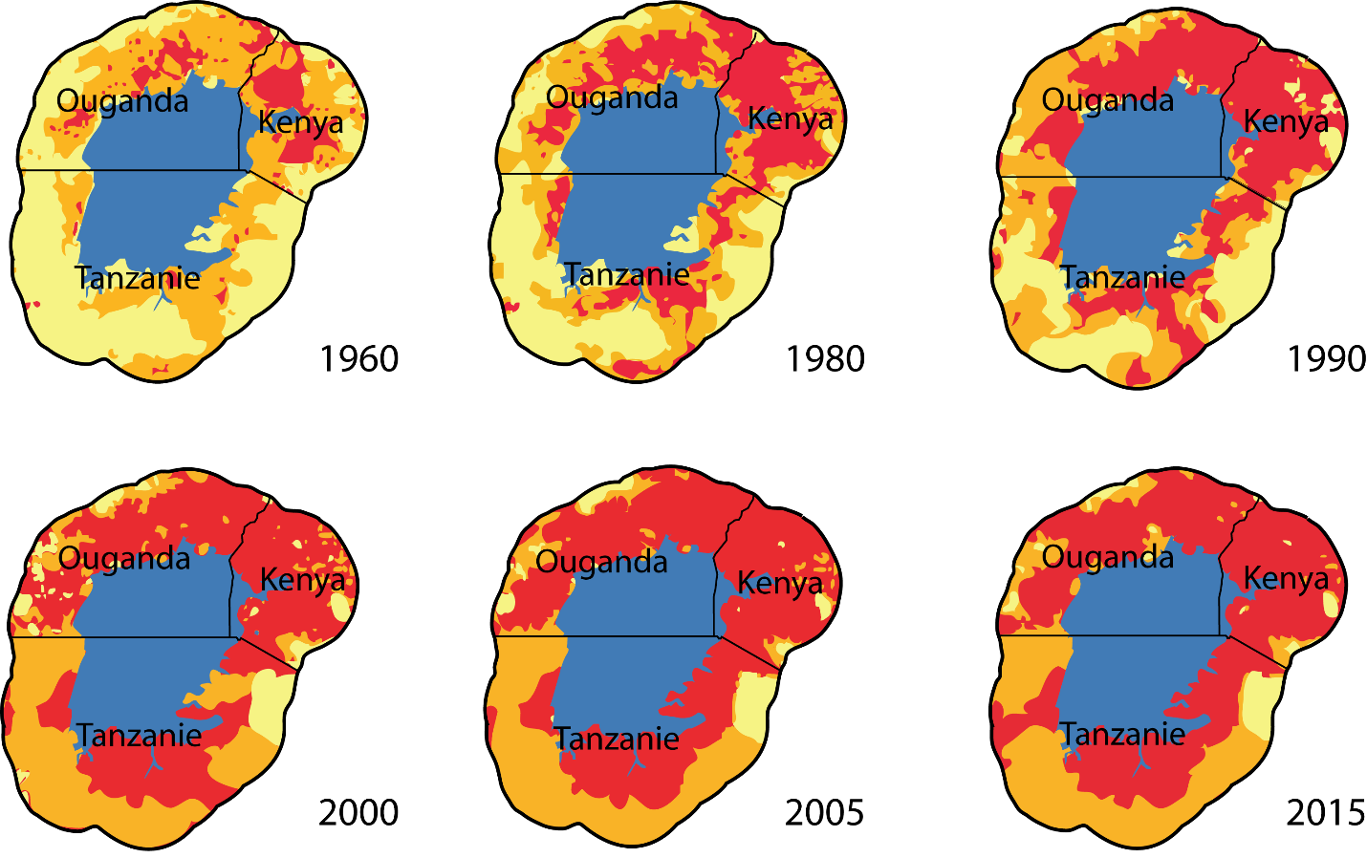

Each group will be looking to observe and gather information about one of the following:
- Desertification of the surrounding land
- Increasing human populations and their use of the lake
- Animal populations being affected through disappearing habitat, breeding grounds, or altered migratory areas
Based on the information you’re gathering, what types of sensors would you need?
Use the rubric and budget given and decide in your group what your subsystems should be.

