Supplementary materials

Contents

2 Performance metrics for other databases 2

2.1 PanTher 2

2.2 JMDC 4

2.3 MDCR 6

3 Correlation between methods 8

4 Outcome Definitions 8

4.1 Acute pancreatitis 8

4.2 GI bleeding 10

4.3 Inflammatory Bowel Disease 12

4.4 Acute stroke (ischemic or hemorrhagic) 13

# Performance metrics for other databases

## PanTher

**Table S.1.1.** Performance metrics on the PanTher database computed using controls with MDRR < 1.25.



**Table S.1.2.** Performance metrics on the PanTher database after calibration computed using controls with MDRR < 1.25.



## JMDC

**Table S.1.3.** Performance metrics on the JMDC database computed using controls with MDRR < 1.25.



**Table S.1.4.** Performance metrics on the JMDC database after calibration computed using controls with MDRR < 1.25.



## MDCR

**Table S.1.5.** Performance metrics on the MDCR database computed using controls with MDRR < 1.25.



**Table S.1.6.** Performance metrics on the MDCR database after calibration computed using controls with MDRR < 1.25.



# Correlation between methods

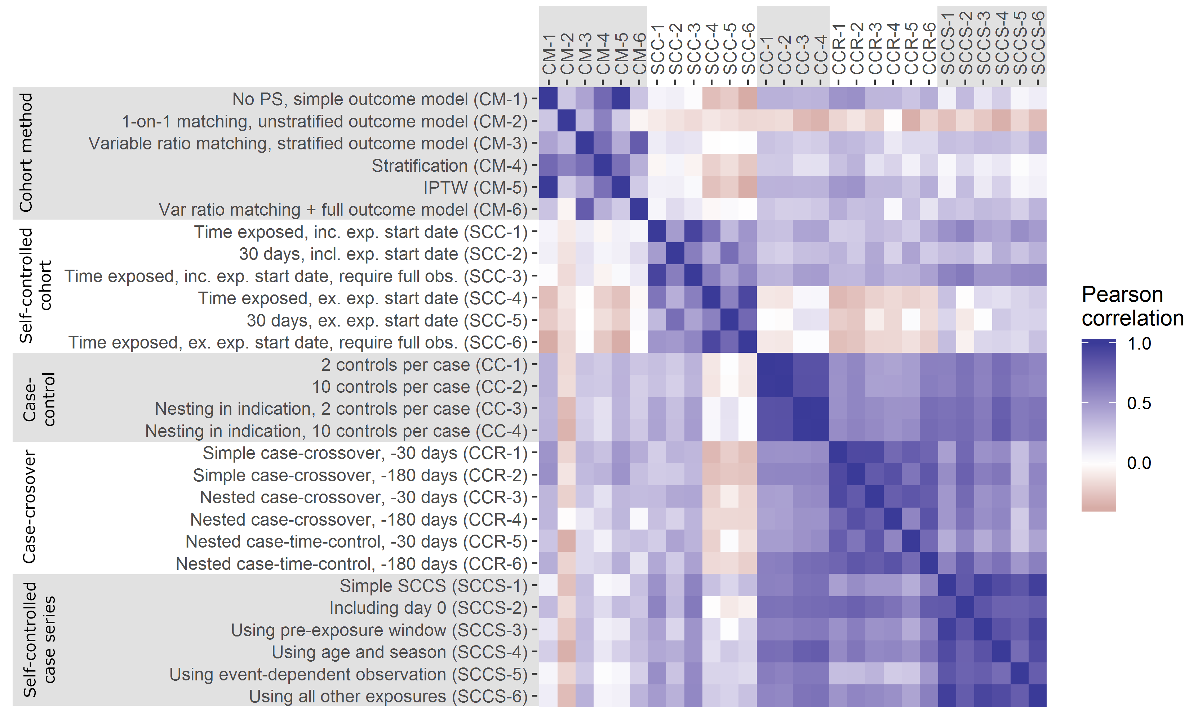

**Figure S.1**. Pearson correlation between the estimates (log(relative risk) of the various methods for negative controls with MDRR < 1.25.

# Outcome Definitions

## Acute pancreatitis

Initial Event Cohort

People having any of the following: 

* a condition occurrence of Acute pancreatitis1
  + condition type is any of Inpatient detail - primary, Inpatient detail - primary position, Inpatient header - primary, Inpatient header - primary position, Primary Condition, Inpatient detail - 1st position
  + visit occurrence is any of: Emergency Room Visit, Inpatient Visit

with continuous observation of at least 0 days prior and 0 days after event index date, and limit initial events to: **earliest event per person.**

Limit qualifying cohort to: **all events per person.**

End Date Strategy

No end date strategy selected. By default, the cohort end date will be the end of the observation period that contains the index event.

Cohort Collapse Strategy:

Collapse cohort by era with a gap size of 0 days.

Appendix 1: Concept Set Definitions

1.  Acute pancreatitis

| **Concept Id** | **Concept Name** | **Domain** | **Vocabulary** | **Excluded** | **Descendants** | **Mapped** |
| --- | --- | --- | --- | --- | --- | --- |
| 199074 | Acute pancreatitis | Condition | SNOMED | NO | YES | NO |

## GI bleeding

Initial Event Cohort

People having any of the following: 

* a condition occurrence of GI bleeding1
  + condition type is any of Inpatient detail - primary, Inpatient header - primary, Primary Condition, Inpatient detail - 1st position, Inpatient header - 1st position
  + visit occurrence is any of: Emergency Room Visit, Inpatient Visit

with continuous observation of at least 0 days prior and 0 days after event index date, and limit initial events to: **earliest event per person.**

Limit qualifying cohort to: **all events per person.**

End Date Strategy

No end date strategy selected. By default, the cohort end date will be the end of the observation period that contains the index event.

Cohort Collapse Strategy:

Collapse cohort by era with a gap size of 0 days.

Appendix 1: Concept Set Definitions

1. GI bleeding

| **Concept Id** | **Concept Name** | **Domain** | **Vocabulary** | **Excluded** | **Descendants** | **Mapped** |
| --- | --- | --- | --- | --- | --- | --- |
| 4280942 | Acute gastrojejunal ulcer with perforation | Condition | SNOMED | NO | YES | NO |
| 28779 | Bleeding esophageal varices | Condition | SNOMED | NO | YES | NO |
| 198798 | Dieulafoy's vascular malformation | Condition | SNOMED | NO | YES | NO |
| 4112183 | Esophageal varices with bleeding, associated with another disorder | Condition | SNOMED | NO | YES | NO |
| 194382 | External hemorrhoids | Condition | SNOMED | NO | NO | NO |
| 192671 | Gastrointestinal hemorrhage | Condition | SNOMED | NO | YES | NO |
| 196436 | Internal hemorrhoids | Condition | SNOMED | NO | NO | NO |
| 4338225 | Peptic ulcer with perforation | Condition | SNOMED | NO | YES | NO |
| 194158 | Perinatal gastrointestinal hemorrhage | Condition | SNOMED | YES | YES | NO |
| 194690 | Nontraumatic hemoperitoneum | Condition | SNOMED | NO | NO | NO |
| 443530 | Hematochezia | Condition | SNOMED | NO | NO | NO |
| 194395 | Bleeding diverticulosis | Condition | SNOMED | NO | YES | NO |
| 4048064 | Hemorrhagic diverticulitis | Observation | SNOMED | NO | YES | NO |

## Inflammatory Bowel Disease

Initial Event Cohort

People having any of the following: 

* a condition occurrence of Inflammatory Bowel Disease (IBD)1

with continuous observation of at least 0 days prior and 0 days after event index date, and limit initial events to: **earliest event per person.**

Limit qualifying cohort to: **all events per person.**

End Date Strategy

No end date strategy selected. By default, the cohort end date will be the end of the observation period that contains the index event.

Cohort Collapse Strategy:

Collapse cohort by era with a gap size of 0 days.

Appendix 1: Concept Set Definitions

1. Inflammatory Bowel Disease (IBD)

| **Concept Id** | **Concept Name** | **Domain** | **Vocabulary** | **Excluded** | **Descendants** | **Mapped** |
| --- | --- | --- | --- | --- | --- | --- |
| 4074815 | Inflammatory bowel disease | Condition | SNOMED | NO | YES | NO |

## Acute stroke (ischemic or hemorrhagic)

Initial Event Cohort

People having any of the following: 

* a condition occurrence of  Acute stroke (ischemic or hemorrhagic)1
  + condition type is any of Inpatient detail - primary, Inpatient detail - primary position, Inpatient header - primary, Inpatient header - primary position, Primary Condition, Inpatient detail - 1st position
  + visit occurrence is any of: Emergency Room Visit, Inpatient Visit

with continuous observation of at least 0 days prior and 0 days after event index date, and limit initial events to: **earliest event per person.**

Limit qualifying cohort to: **earliest event per person.**

End Date Strategy

No end date strategy selected. By default, the cohort end date will be the end of the observation period that contains the index event.

Cohort Collapse Strategy:

Collapse cohort by era with a gap size of 0 days.

Appendix 1: Concept Set Definitions

1.  Acute stroke (ischemic or hemorrhagic)

| **Concept Id** | **Concept Name** | **Domain** | **Vocabulary** | **Excluded** | **Descendants** | **Mapped** |
| --- | --- | --- | --- | --- | --- | --- |
| 374060 | Acute ill-defined cerebrovascular disease | Condition | SNOMED | NO | YES | NO |
| 376713 | Cerebral hemorrhage | Condition | SNOMED | NO | YES | NO |
| 4108356 | Cerebral infarction due to embolism of cerebral arteries | Condition | SNOMED | NO | YES | NO |
| 4110192 | Cerebral infarction due to thrombosis of cerebral arteries | Condition | SNOMED | NO | YES | NO |
| 4043731 | Infarction - precerebral | Condition | SNOMED | NO | YES | NO |
| 4345688 | Intracerebral hemorrhage in fetus or newborn | Condition | SNOMED | YES | YES | NO |
| 42873157 | Intracranial hemorrhage following injury | Condition | SNOMED | YES | YES | NO |
| 260841 | Perinatal subarachnoid hemorrhage | Condition | SNOMED | YES | YES | NO |
| 432923 | Subarachnoid hemorrhage | Condition | SNOMED | NO | YES | NO |
| 441709 | Subarachnoid hemorrhage following injury with open intracranial wound | Condition | SNOMED | YES | YES | NO |
| 443752 | Ventricular hemorrhage | Condition | SNOMED | YES | YES | NO |